**Design Thinking**

**Final Learning Essay**

**Submitted by: Ganesh Shelke (TLP’23)**

**Submitted to: Prof. Dr. Jitesh Panchal**

By my signature below, I certify that I have not received improper help nor given it to others in writing this assignment nor have I used any method that would give me an unfair advantage over others in the class. This assignment represents my own work only and I had no assistance from another person or any other source unless it is referenced at the bottom of each appropriate page.

Ganesh Shelke 03-01-2023 “ Final Learning Essay”

*Design thinking is a discipline that uses the designer's sensibility and methods to match people's needs with what is technologically feasible and what a viable business strategy can convert into customer value and market opportunity."*

*– Tim Brown, CEO of IDEO*

**Design Thinking Overview**

In the introductory class, I got to know the professor and his teaching style. The most crucial question I had was about the lack of creativity and how it would impact me in my career as a product manager. When asked, the professor kindly answered that everyone is creative and you don’t need to be good at it. It is an art and can be learned with time and practice. When told about my inferiority complex due to having a friend who is good at drawing, he reassured me that even though I am not good at drawing and related skills, I can always delegate that task to someone good at it and focus on the actual product strategy & road mapping, product analytics, launch, and marketing aspects. The freewheeling discussion on what design means and how it relates to other fields including the interesting definition of “Design is to design a design to produce a design” created immense interest in this course.

Then we had an opportunity to do a hands-on Design activity where we were asked to design a backpack for our partner. This was my first experience in a long time to visualize and draw something, within a short amount of time. I designed a backpack somewhat similar to my laptop bag. In the next step, I realized that I didn’t take into account that what my partner needed was different. I assumed that his needs must be similar to mine. Documenting his need and empathizing with him helped me create my problem statement that he needs a way to carry things especially when he travels to different places, for 2-3 days with 4-5 pairs of clothes along with chargers, notepads, and a book. Then I sketched 3 radical ideas to propose to him the solution and the one he chose was a bag, an improved version of a suitcase, which would have separate compartments for quick removal of the laptop, clothes parallel to each other, and on the other side there would be small compartments for the charger, water bottle and pen. The aim was to make it convenient and quick to take things out while traveling without keeping the bag horizontally on the surface. Though I thought this could be the final version, after getting feedback from him, I came to know that he also needs a quicker way to remove his clothes, with a special mechanism to take out the clothes properly by adding separators between pairs of clothes.

The learnings from this activity were to ask the user about their specific needs, use my imagination to give the user multiple options and get feedback constantly, and iterate and improve it. This activity also helped me to look at how other designers (partners) were thinking, sometimes it may happen that users don’t need the radical solution, they might just need a simple, improved solution to their needs. As every user group is different, the product is never complete (well, if the company creates a full-fledged product at the beginning itself, it may be overwhelming & costly and it will take so long that they might just lose an opportunity to some other competitor who has a just good product built and released quickly.

I also got an opportunity to read an article by Tim Brown.[1] In the HBR article "Design Thinking," Tim Brown discusses the concept of design thinking as a solution-focused approach to problem-solving. He explains that design thinking involves empathy, experimentation, and iteration to create innovative and effective solutions. Brown argues that design thinking can be applied to a wide range of industries and challenges and that it is particularly useful in complex and uncertain situations.

**Understanding the Problem**

*“The mere formulation of a problem is far more important than its solution, which may be merely a matter of mathematical or experimental skills.”*

*– Albert Einstein*

Different designers use different methodologies according to their needs. The ones that I used here as a part of the course were the methodology with two diamonds and the phases of the design thinking process.

In two diamonds method, the first diamond signifies the problem and the second one shows the process and the ways to implement the solution. The thing I liked the most in this methodology is that it doesn’t end at the second diamond, but it keeps track of everything by evolving the product and keeping it relevant and updated to the market needs

The second methodology is where we walked through the phases of the Design Thinking Process. This was the body and backbone of the course as we were going to learn each phase in detail and apply it to our design project. The most crucial part of this process was to understand the problem and once it is done, we can move to the next phases in the process: Empathy, Define, Ideate, Prototype and Test.

*"People don't buy what you do; they buy why you do it. And what you do simply proves what you believe."*

*- Simon Sinek, Start With Why: How Great Leaders Inspire Everyone to Take Action*

Well, to understand the problem, we used a tool named “5x Why”. This exercise was particularly difficult as we were diverging to think about the solution instead of the problem. This tool helped us as a team to go deeper to understand why this problem is important and what not just scratch the surface. These multiple “why” questions helped us to reach the fundamental objective and understand why this is the problem that needs to be solved. The other tool “5 WH Questions” helped us to think about the problem from a different perspective which later formed the base for user interview questions. The first design brief that we are going to create would be based on these tools.

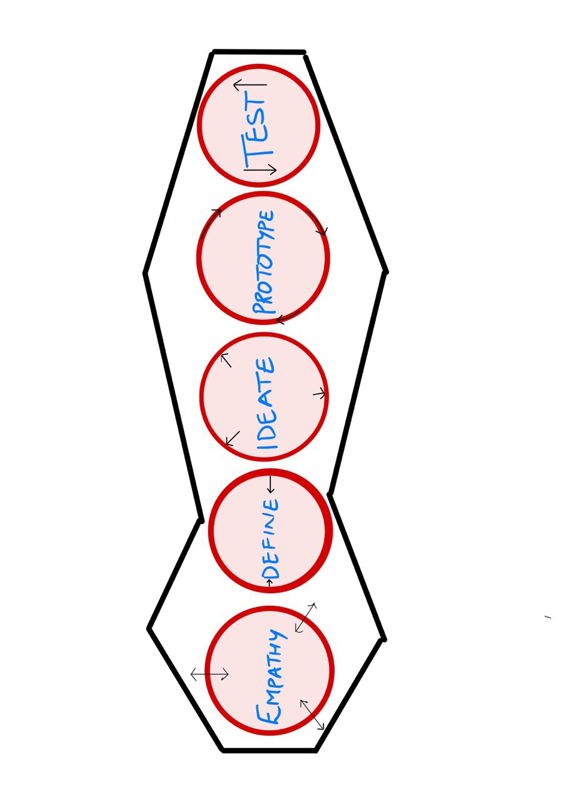

Fig. 1: Phases in Design Thinking

**Empathy**

Empathy is a crucial element in design thinking. It allows us to understand the needs, desires, and pain points of our users in a deeper, more meaningful way. By observing, engaging, and immersing ourselves in the experiences of others, we can create solutions that truly resonate with and improve their lives.

As Tim Brown, CEO of IDEO, stated, *"Empathy is not just about trying to understand how someone else is feeling; it's about taking that understanding and using it to create meaningful change."* By incorporating empathy into our design process, we can create products, services, and experiences that truly make a difference in the world.

To effectively practice empathy in design thinking, it's important to begin by observing the people we're designing for. This means paying attention to their behaviors, needs, and emotions in a non-judgmental way. We can then engage with them, asking questions and actively listening to their responses to gain a deeper understanding of their experiences. Finally, we can immerse ourselves in their lives by walking in their shoes, participating in their daily routines, and getting a firsthand look at their challenges and opportunities.

By following this empathic approach, we can design solutions that truly meet the needs of our users and create meaningful change in the world. As designers, it's our responsibility to use our skills and talents to make a positive impact on the lives of others, and empathy is a powerful tool that can help us do just that.

In the Youtube video shown to us, Tom Kelley discusses the importance of using field observations to gather new insights and ideas.[2] He emphasizes the need to approach observations with a sense of curiosity and an open mind, rather than preconceived notions or assumptions. Kelley advises observing with "fresh eyes," or the ability to see the world as if for the first time, to truly capture the nuances and details of a situation. He also encourages actively seeking out diverse perspectives and engaging with people in the field to gain a fuller understanding of a topic. Kelley emphasizes the value of field observations as a tool for innovation and problem-solving.[2]

For my project, I had users from diverse backgrounds across the world from all continents except Antarctica, and I could empathize with each user putting myself in their shoes. The stories of some users were no less than a scene in horror movies when they faced this problem on their arrival in India. We had:

* 3 International Students, facing severe problems
* 4 NRIs, frustrated with Indian banks
* 5+ tourists, looking for convenience.

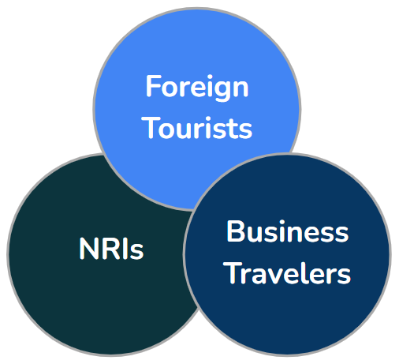

Key insights from our users:

* The problems here are highly interconnected, and revealed themselves through users: Payment led to Sim Card led to banks.
* Nearly every single user reported payments as a substantial problem, indicating a severe need.
* Emotions most associated with the problem included frustration, annoyance, and helplessness.

**Point of View**

Convergence: Point of View to define the problem was a very enlightening topic for me in my design thinking journey. It emphasized the importance of considering multiple perspectives and viewpoints when defining a problem.

Before this topic, I tended to focus solely on my perspective and biases when defining a problem. I would often come up with solutions that only addressed my own needs and desires, without considering the needs and desires of others.

However, after learning about convergence and the importance of considering multiple viewpoints, I now understand the value of gathering diverse perspectives and incorporating them into the problem-definition process. This helps to ensure that the problem is more accurately defined and that potential solutions will be more inclusive and effective.

This has helped me to understand the value of considering multiple viewpoints and the importance of empathy in the design thinking process. It has opened my eyes to the benefits of gathering diverse perspectives and has made me a more effective problem solver.

**Idea Generation**

The step of idea generation was helpful and one of the most interesting parts of the course. From all the options available to generate creative ideas, we chose the Brainwriting technique, also called as 6-3-5 method, particularly for it’s easy to start nature and to build on the previous ideas, with elements as group size, three ideas in five minutes and passed to others to get three ideas each, where the sheet changes hands for each member. In our case, it was 4-3-3.

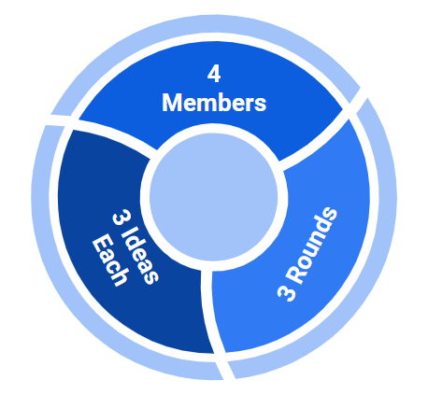

I found this method to be very effective in generating a wide range of ideas and getting everyone in the group involved. The time constraints helped to keep the group focused and prevented the brainstorming from becoming stagnant. It also allowed for a variety of perspectives and ideas to be shared, as each team member had the opportunity to contribute their unique ideas.

One aspect of the 6-3-5 method that I found particularly helpful was the selection of the three best ideas. This helped to narrow down the focus and allowed the group to concentrate on developing and refining a smaller number of ideas. It also allowed for a more in-depth discussion and exploration of the chosen ideas.

Key insights from ideation:

* While practicing 4-3-3, a lack of complete understanding of the idea leads to new ideas
* The morphological analysis enabled us to think of wacky solutions e.g. crypto transfer via sms

**Structuring and Selecting Ideas**

In the process of design thinking, structuring and selecting ideas is a crucial step. It involves organizing and evaluating the various ideas generated during the ideation phase, to identify which ones have the most potential to be developed further.

The approach we used for structuring and selecting ideas is to use a matrix or grid, where each idea is evaluated based on specific criteria such as feasibility, impact, and alignment with the project goals. This can help to clarify the strengths and weaknesses of each idea and make it easier to identify the most promising ones.

One challenge we have faced in this process has been the tendency to become attached to certain ideas and to resist letting go of them. This has required us to be open to feedback and to be willing to question our assumptions and biases.

The goal of structuring and selecting ideas is to identify those that are most feasible, impactful, and aligned with the project goals, and to prioritize them for further development. This requires a combination of analytical thinking and creative thinking, as well as the ability to evaluate and compare different ideas objectively.

After structuring our idea into the Value vs Effort matrix, we realized that the most sought-after box, High Value & Low Effort, was empty which first made us nervous but also gave us the reality check that some problems need a solution that is not always achieved with low effort. We then focused on the High Value & High Effort box.

Finalizing the best solution idea was the most time-consuming activity for us as a group but it was worth the time and effort we put in as that helped us to focus on what we needed to do to start the prototyping.

|  |  |  |
| --- | --- | --- |
|  | **Low Effort** | **High Effort** |
| **Low Value** | - ATM Assistance (Map, info, etc)  - “Phone-a-friend” support service  - Crypto Payment Ecosystem | - Virtual Cards  - Cash Delivery  - Forex for Vendors |
| **High Value** |  | - Wallet to UPI  - POS Machines  - NFC Payments |

**Prototyping**

Prototyping is a crucial step in the design thinking process as it allows us to test and tangibly iterate on our ideas. As Thomas Edison once said, *"I have not failed. I've just found 10,000 ways that won't work."* Prototyping allows us to discover what works and what doesn't, and to continue refining our ideas until we arrive at a solution that meets the needs of our users.

One of the key insights I gained through prototyping is the importance of getting feedback from users early and often. As Henry Ford famously said, *"If I had asked people what they wanted, they would have said faster horses."* By creating low-fidelity prototypes and testing them with users, we can get a better understanding of their needs and desires, and adjust our designs accordingly.

Another valuable lesson I learned through prototyping is the importance of flexibility and adaptability. As Albert Einstein once said, "*The only source of knowledge is experience."* Prototyping allows us to learn from our experiences and make adjustments as needed, rather than committing to a final solution before we have fully explored all of our options.

Prototyping has been a valuable tool for me in the design thinking process. It has allowed me to test and iterate on my ideas, gather valuable feedback from users, and remain flexible and adaptable as I continue to explore and refine my designs.

**User Testing**

User testing is a crucial step in the design thinking process as it allows us to gather valuable feedback from real users about our design. As the famous quote by Steve Jobs goes*, "Design is not just what it looks like and feels like. Design is how it works."* User testing helps us understand how our design works in the hands of the user and allows us to identify any pain points or areas for improvement.

Another quote that I find valuable is, *"The best design is intuitive. It should be invisible."* - Jony Ive. Through user testing, designers can identify any areas of confusion or frustration for users and make adjustments to create a more intuitive design.

One thing that I have learned through user testing is the importance of understanding the user's perspective. It is easy to get caught up in our ideas and assumptions about how the user will interact with our design, but user testing allows us to see firsthand how they use it. As the quote by Donald Norman goes, *"The designer is not the user's advocate; the user is the designer's advocate."* It is our job as designers to put ourselves in the user's shoes and design for their needs, not just for our aesthetic preferences.

Another lesson I learned from user testing is the value of iterative design. We can't always get it right on the first try, and that's okay. As the saying goes, *"Fail fast, fail often."* By quickly prototyping and testing our ideas, we can quickly identify any issues and make necessary adjustments. As Tim Brown, CEO of IDEO, states, *"Failures are just an opportunity to begin again more intelligently."*

User testing has helped me to better understand the needs and desires of my target audience and create designs that are more tailored to their needs. It is a valuable tool that has greatly improved the effectiveness of my designs.

I specifically liked how testing can be made interesting when I saw the bodystorming video.[3] A team of designers donned their acting hats to bring the movie ticket purchasing process to life in a wacky bodystorming session. They pretended to be movie-goers of all kinds, from online ticket buyers to theatergoers, to see where the process might trip them up. No stone was left unturned as they identified pain points and brainstormed solutions for a smoother ticket-buying experience. By the end of the performance, they had a whole host of ideas for making buying tickets a breeze. Who says design can't be fun?

Though we couldn’t complete our user testing due to time constraints we look forward to testing it in the next phase (ECL) as I feel that user testing.

**Summarizing my Learnings:**

Through the course on design thinking, I have learned that this approach to problem-solving involves understanding the needs and perspective of the user, prototyping and testing ideas, and continuously iterating to improve upon them. It emphasizes empathy, creativity, and collaboration to find innovative solutions to complex challenges. One key takeaway for me was the importance of empathy in the design process. By really understanding the needs and experiences of the user, we can create products and services that not only look and feel good but also function effectively and efficiently. This Design Thinking course has provided me with a valuable framework for approaching problem-solving and helped me develop skills in creative thinking and collaboration.

Some key takeaways while working on the project:

* Creativity blooms at the edge of ambiguity
* No ideas are bad
* Empathy leads to the discovery
* Do not fall in love with the idea/product
* Build fast, evaluate fast
* Room for sharing stories

*"Design thinking is like being stuck in a washing machine: you get tossed around, you go round and round, but eventually, you come out clean."*

* *Unknown*

**References:**

1. Brown, Tim. (June 2008). Design Thinking, Harvard Business Review.
2. Tom Kelley: Field Observations with Fresh Eyes,

<https://www.youtube.com/watch?v=XrpAveg7ZIg>

1. Bodystorming movie ticket prototype:

<https://www.youtube.com/watch?v=AoWAnY2La5k>

1. Prof. Panchal, Jitesh, Desing Thinking Course